Phillip Jauregui

Project 3 Design Doc

User Stories:

* User changes password/name
  + Common Use Cases
    - User changes password
      * User changes password
      * Password is changed
    - User changes name
      * User changes name
      * Name is changed
* Admin
  + Common Use Cases
    - Admin adds new user
      * Admin adds new user
      * New user is successfully added
    - Admin updates user
      * Admin updates existing user
      * Existing user is successfully updated
* Manage Product
  + Common Use Cases
    - User Loads a Product
      * User loads a product
      * Product loads successfully without conflict
    - User Saves a Product
      * User edits a product/creates a new one
      * User saves product
      * Product saves successfully without conflict
  + Exception
    - User loads a product
      * User loads a product
      * Product fields conflict with type of fields or fields don’t exist
      * Product doesn’t load successfully
    - User saves a product
      * User edits a product/creates a new one
      * Product fields conflict with type of fields or existing fields in other products
      * Product doesn’t save successfully
* Manage Customer
  + Common Use Cases
    - User Loads a Customer
      * User loads a customer
      * Customer loads successfully without conflict
    - User Saves a Customer
      * User edits a customer/creates a new one
      * User saves customer
      * Customer saves successfully without conflict
  + Exception
    - User loads a customer
      * User loads a customer
      * Customer fields conflict with type of fields or fields don’t exist
      * Customer doesn’t load successfully
    - User saves a customer
      * User edits a customer/creates a new one
      * Customer fields conflict with type of fields or existing fields in other customers
      * Customer doesn’t save successfully
* Manage Purchase
  + Common Use Cases
    - User Loads a Purchase
      * User loads a purchase
      * Purchase loads successfully without conflict
    - User Saves a Purchase
      * User edits a purchase/creates a new one
      * User saves purchase
      * Purchase saves successfully without conflict
  + Exception
    - User loads a purchase
      * User loads a purchase
      * Purchase fields conflict with type of fields or fields don’t exist
      * Purchase doesn’t load successfully
    - User saves a purchase
      * User edits a purchase/creates a new one
      * Purchase fields conflict with type of fields or existing fields in other purchases
      * Purchase doesn’t save successfully

Main Screen

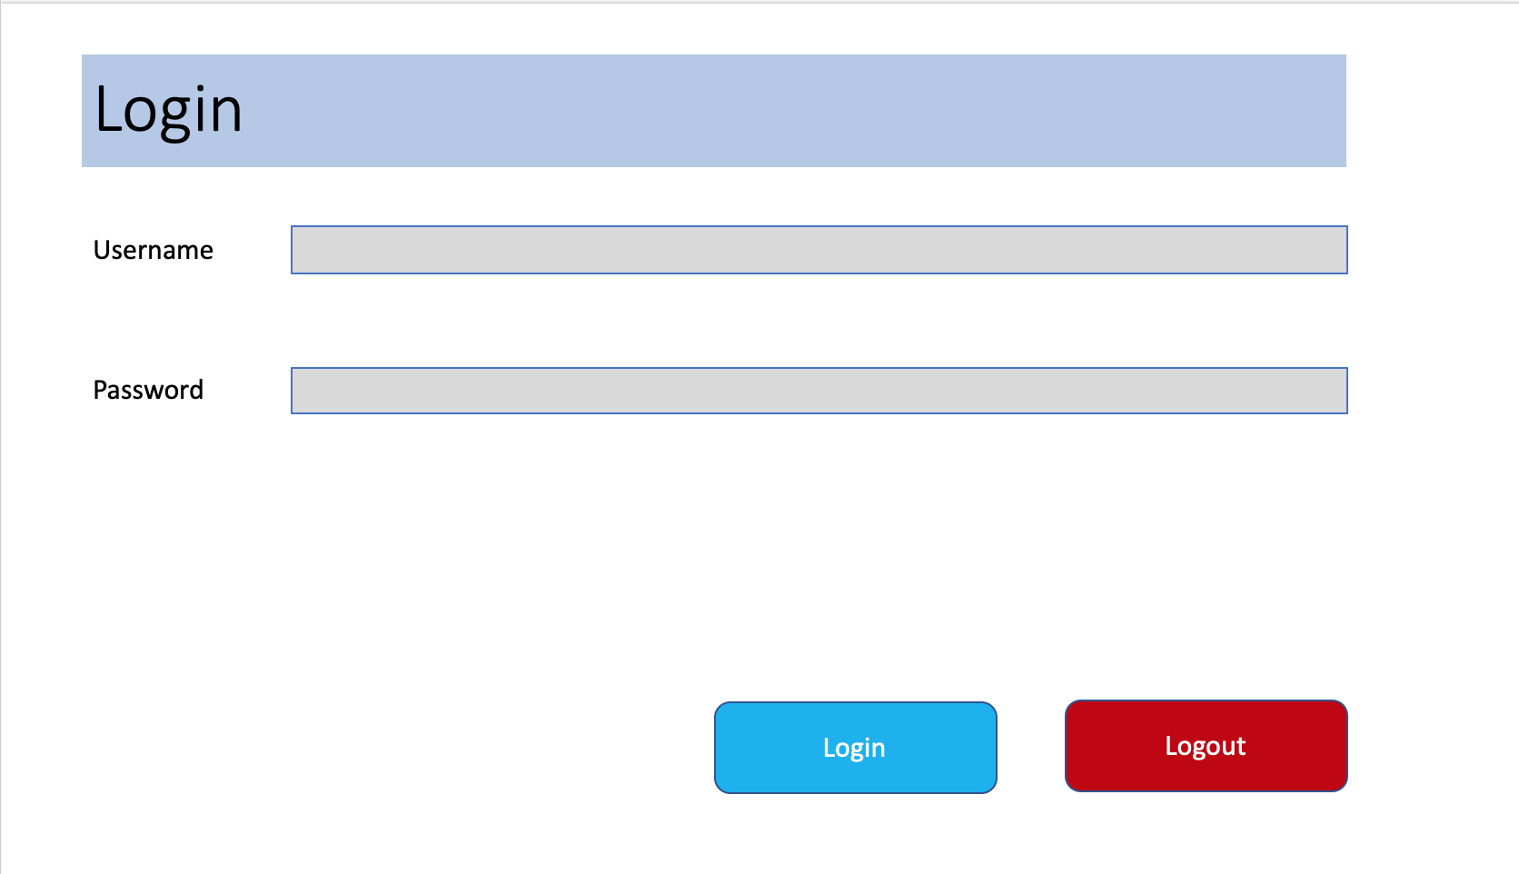

Login Successful:

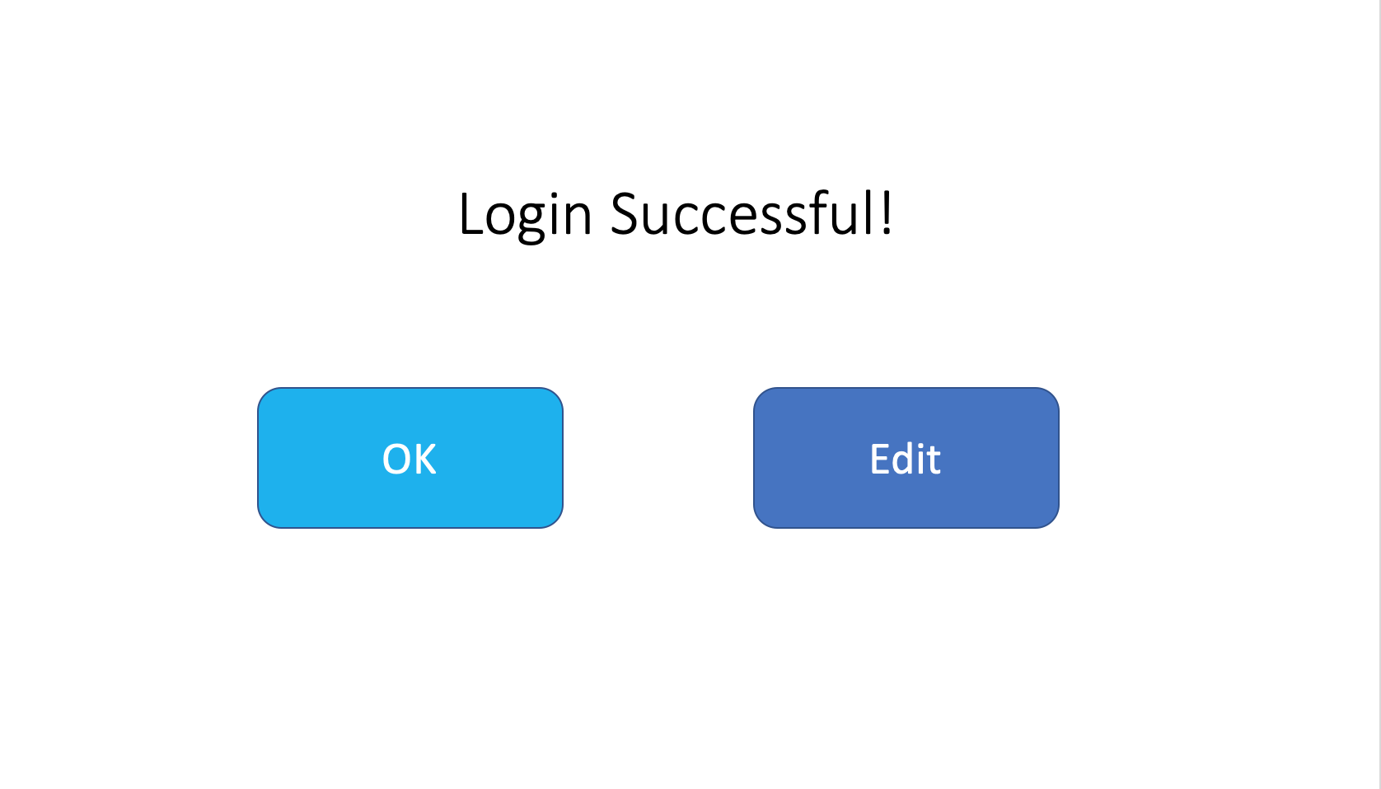

Edit User Login Values:

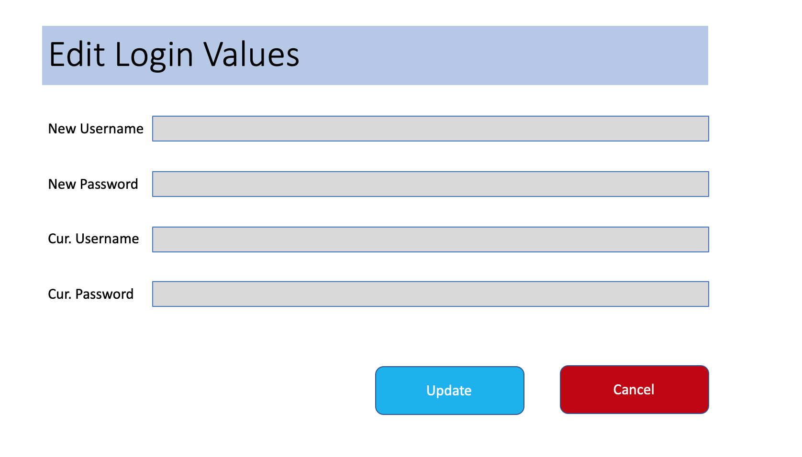

Admin:

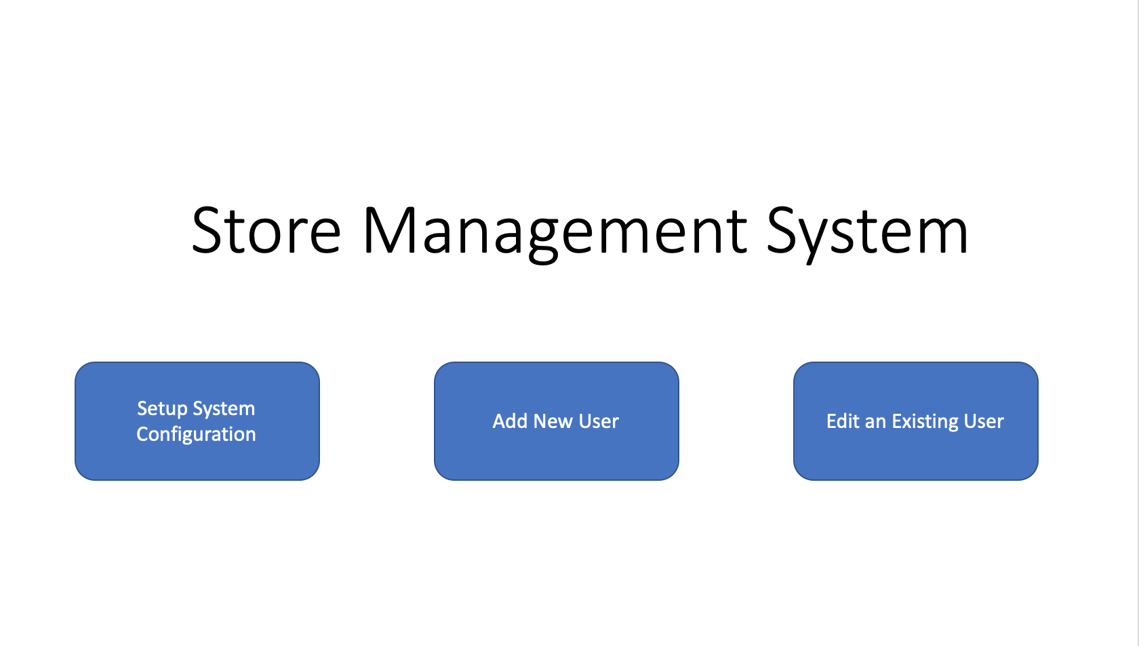

Manager:

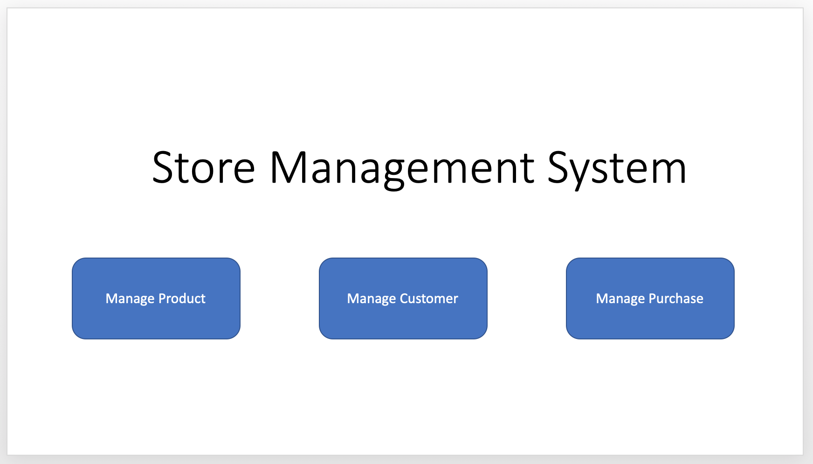

Manage Product:

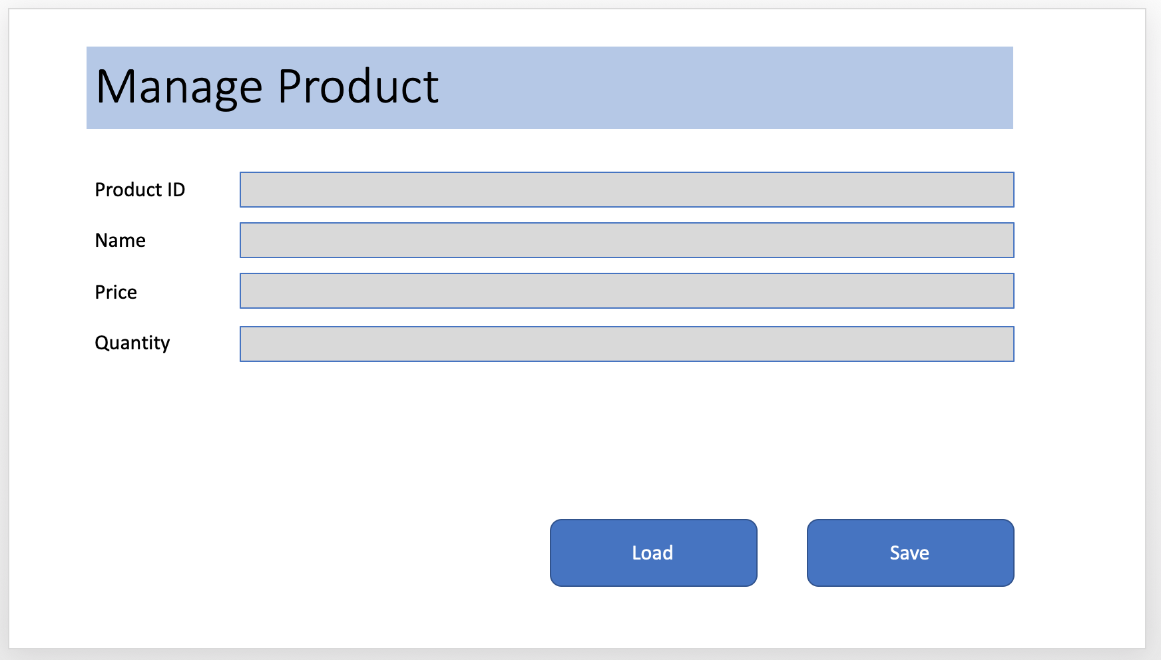

Product Saved:

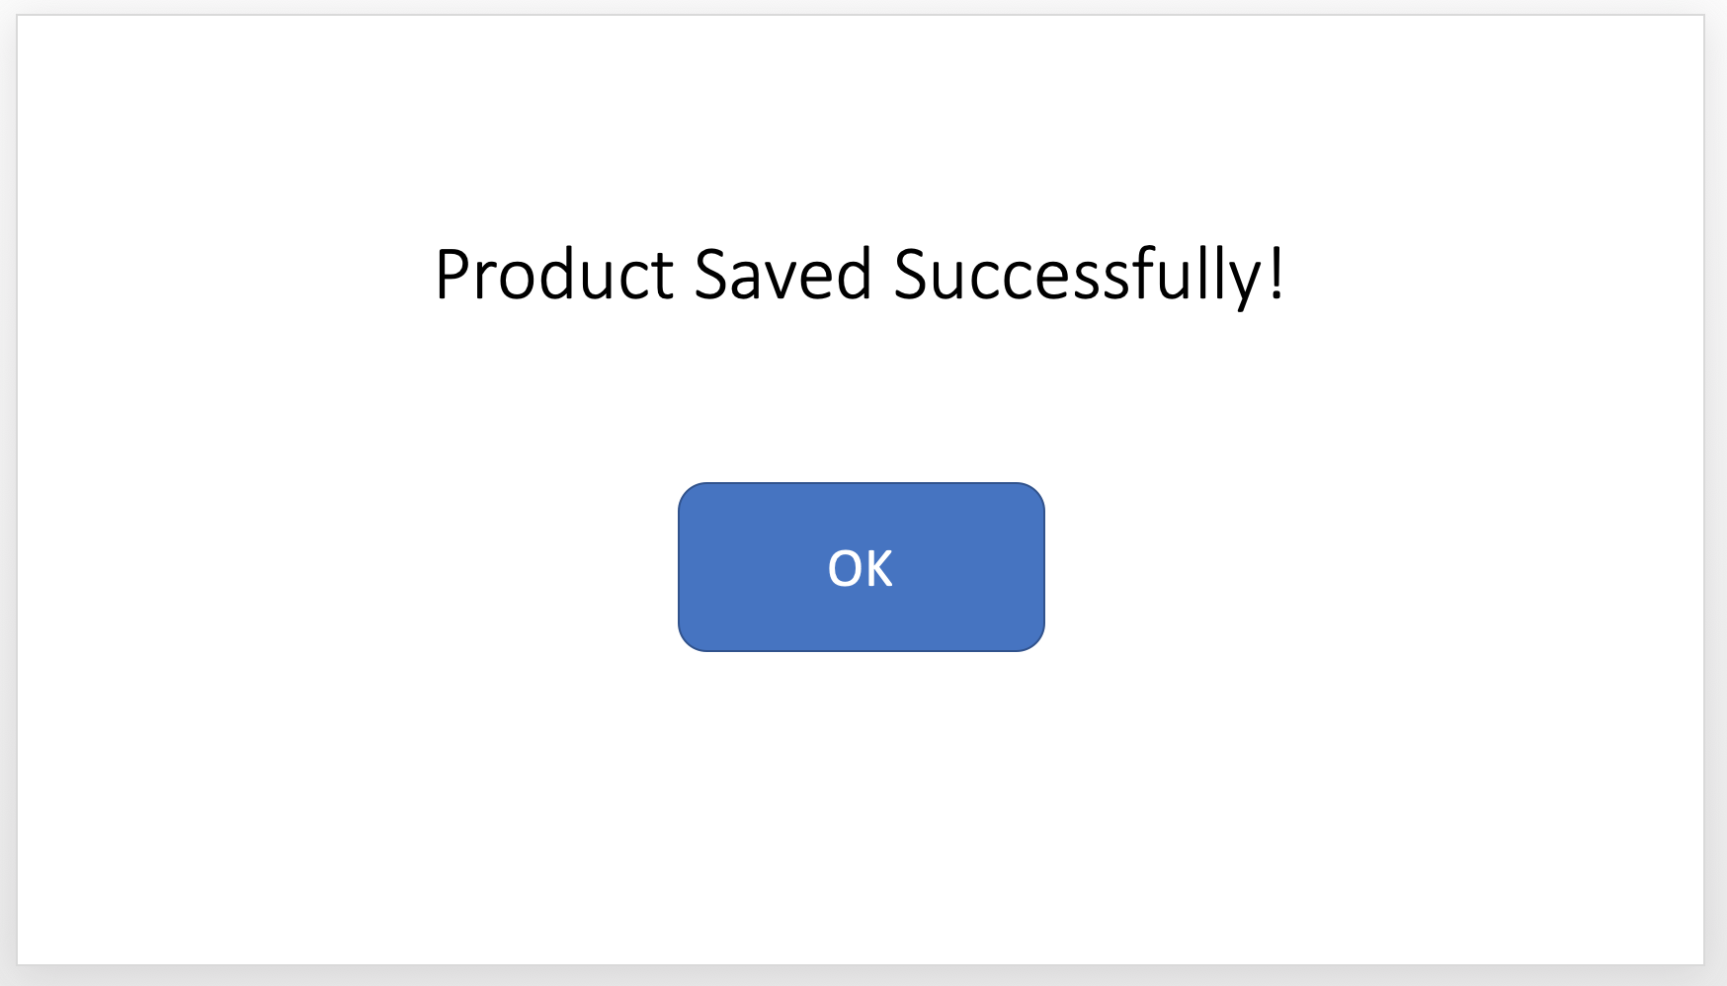

Manage Customer:

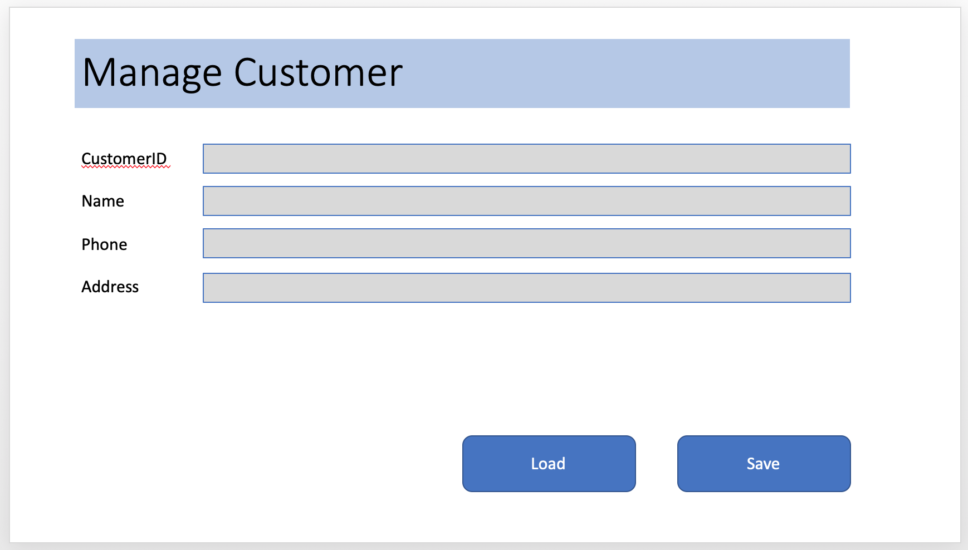

Customer Saved:

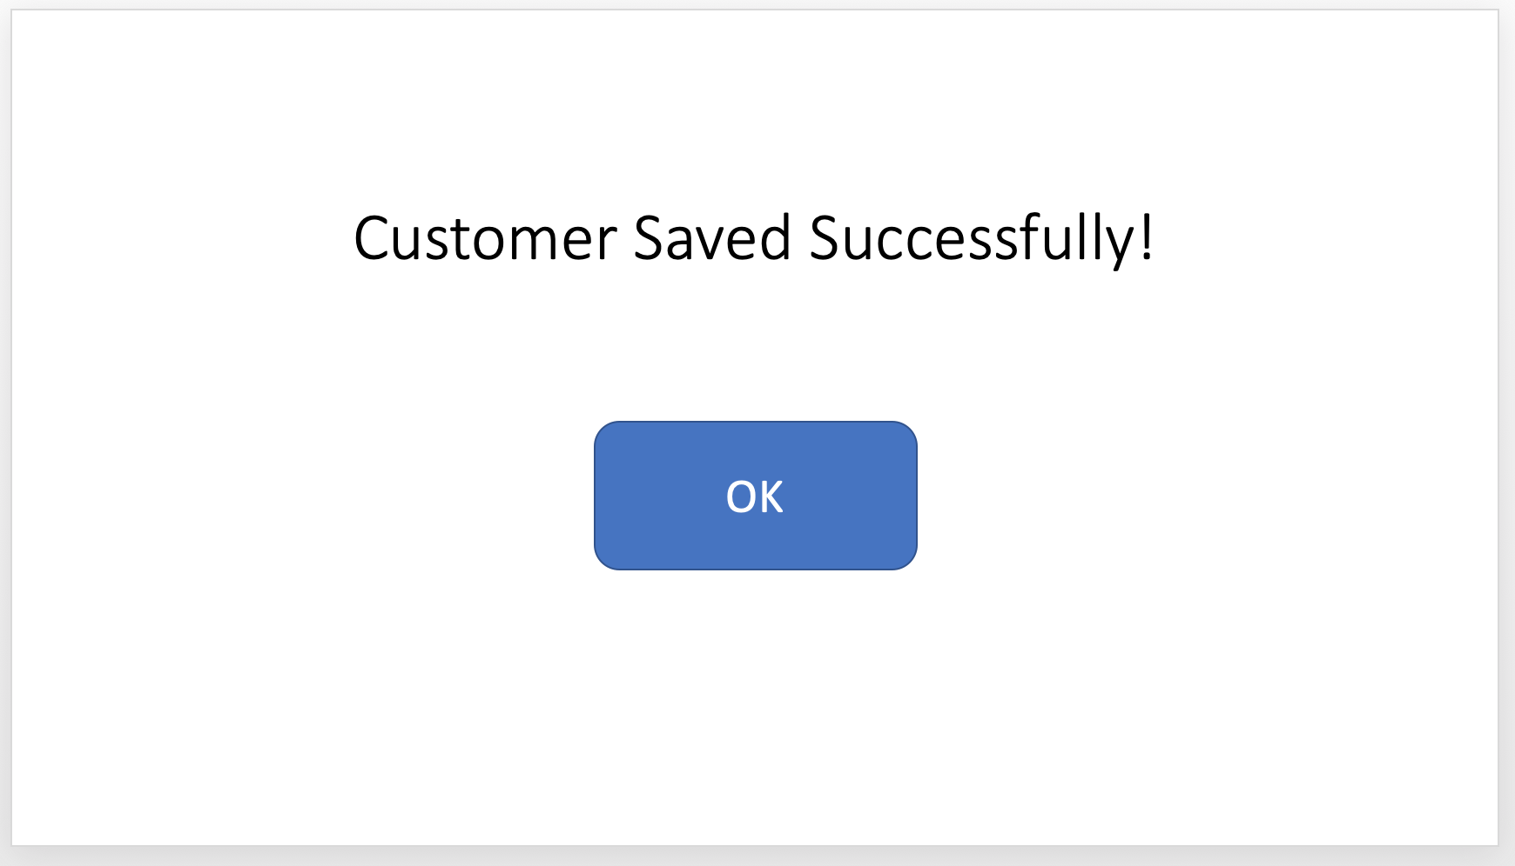

Manage Purchase:

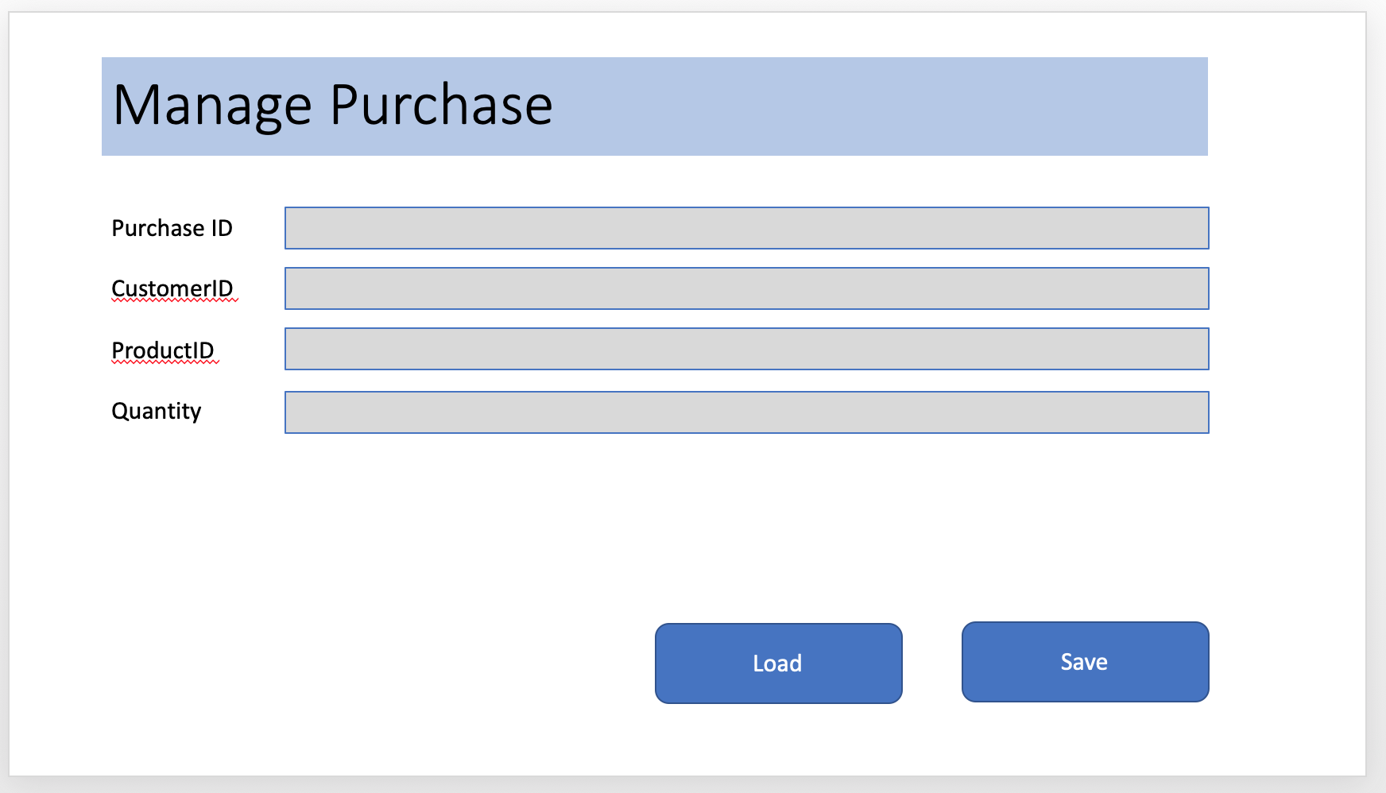

Purchase Saved:

